OHDSI Drug Utilization in Children Protocol:

Exploration of drug utilization in children in Asia

**Authors:**

Ian Wong, PhD, University of Hong Kong

Kenneth Man, MPH, University of Hong Kong

Martijn Schuemie, PhD, Janssen Research and Development

Nicole Pratt, PhD, University of South Australia

Rae Woong Park, MD, PhD, Ajou University School of Medicine

Soo-Yeon Cho, Ajou University School of Medicine

Jack Li, MD, PhD, Taipei Medical University

Usman Iqbal, PhD, Taipei Medical University

Alex Nguyen, PhD, Taipei Medical University

**Date:** 8 September 2015

**Acknowledgement:** The analysis is based in part on work from the Observational Health Sciences and Informatics collaborative. OHDSI (<http://ohdsi.org>) is a multi-stakeholder, interdisciplinary collaborative to create open-source solutions that bring out the value of observational health data through large-scale analytics.

The authors declare the following disclosures: Dr. Schuemie is an employee of Janssen Research & Development.

Contents

Background 3

Objective 3

Data sources 3

Ajou University School of Medicine (AUSOM) 3

Hong Kong Clinical Data Analysis and Reporting System (CDARS) 4

Japan Medical Data Center (JMDC) 4

Taiwan’s National Health Insurance Research Database (NHIRD) 5

Australian Pharmaceutical Benefits Scheme (PBS) 10% Sample Data 5

Data collection 5

Population 5

Methods 5

Table and figure shells 6

References 13

# Background

There is a lack of evidence regarding the safety and efficacy of drugs used in children. Most drugs prescribed to children are the same as those originally developed for adults, and are often prescribed simply by extrapolating evidence for adults. Diseases in children, however, might be different from their adult equivalents, and the process underlying growth and development might lead to a different effect or an adverse drug reaction unseen in adults.

Observational data in the form of electronic health records and insurance claims data have the potential to fill this knowledge gap through retrospective analysis of drug exposure in children and its consequences. A first step is to make an inventory of the drugs taken by children, and the prevalences with which they are prescribed. Previous research in Europe (1) has shown large differences in prescribing patterns between countries, making it difficult to generalize to other countries, let alone other regions. In this study we want to focus on pediatric drug use specifically in Asia.

# Objective

We aim to measure the prevalence of drug use in children in several countries in Asia. We will compute prevalence for all drugs captured in the databases in the pediatric population. The main analysis will focus on drug classes (anatomical and therapeutic) and these prevalences will be stratified by year to evaluate temporal trends. A secondary analysis will report the five top ingredients per anatomical class per country. All analysis will be stratified by age (< 2 years, 2-11 years, and 12-18 years), and by setting (inpatient or ambulatory care).

# Data sources

The analyses will be performed across a network of observational healthcare databases. All databases have been transformed into the OMOP Common Data Model, version 4 or OMOP Common Data Model, version 5. The complete specification for OMOP Common Data Model, version 4 is available at: <http://omop.org/cdm>. The complete specification for OMOP Common Data Model, version 5 is available at: <https://github.com/OHDSI/CommonDataModel>. The following databases will be included in this analysis:

* Ajou University School of Medicine (AUSOM)
* Hong Kong Clinical Data Analysis and Reporting System (CDARS)
* Japan Medical Data Center (JMDC)
* Taiwan’s National Health Insurance Research Database (NHIRD)
* Australian Pharmaceutical Benefits Scheme (PBS) 10% Sample Data

## Ajou University School of Medicine (AUSOM)

AUSOM is an electronic health record (EHR) database of a Korean tertiary teaching hospital with 1,096 patient beds and 23 operating rooms that adopted a computerized provider order entry (CPOE) system in 1994 and a comprehensive EHR system in March 2010. The AUSOM database contains 2,073,120 individuals, 18,717,764 conditions (diagnoses), 99,331,794 drug exposures, and 15,002,879 procedures.

ACHILLES has been used to characterize the database and provide a data quality assessment. The ACHILLES summary is available at:

<http://ami.ajou.ac.kr:8080/#/AUSOM/dashboard>

## Hong Kong Clinical Data Analysis and Reporting System (CDARS)

CDARS is an electronic health record (EHR) database which is developed and maintained by the Hong Kong Hospital Authority (HA), a statutory body which manages all public hospitals and their associated ambulatory and primary care clinics. The service is available to all HK residents (over 7 million) and covers about 80% of all hospital admissions in HK. Patient-specific clinical data including diagnoses, prescription and information on admission and discharge which are recorded by trained clinicians. Other patient-specific data such demographics, payment method, prescription and pharmacy dispensing information are entered by other trained staff. CDARS contains records of in-patient, out-patient, primary care clinics and emergency room admissions in HA since 1995. Records are anonymized to protect patient confidentiality. Data from CDARS has been used for various pharmacoepidemiological studies and has been demonstrated to be a reliable database for research (2-4).

For this study, 86,526 patients were randomly selected to develop a subset of cohort; consequently OMOP Common Data Model could be used for data analysis. The protocol was approved by the Institutional Review Board of the HK Hospital Authority West Cluster (Reference number: UW 13-504).

ACHILLES has been used to characterize the database and provide a data quality assessment. The ACHILLES summary is available internally within the University of Hong Kong at: <http://10.99.109.98/achilles/#/CDARS/dashboard>

## Japan Medical Data Center (JMDC)

JMDC consists of data from 60 Society-Managed Health Insurances covering workers aged 18 to 65 and their dependents (children and elderly). The claims data are derived from monthly claims issued by clinics, hospitals and community pharmacies. Data capture is from July 2009 onwards. Drugs in JMDC are coded using a national drug code, which has been mapped to RxNorm.

ACHILLES has been used to characterize the database and provide a data quality assessment. The ACHILLES summary is available internally within Janssen at: <http://hix.jnj.com/achilles/#/jmdc/dashboard>.

## Taiwan’s National Health Insurance Research Database (NHIRD)

The reimbursement data from the Bureau National Health Insurance (NHI) system in Taiwan has registered all medical claims since 1995. More than 99% of the citizens of Taiwan are enrolled in the NHI, which offers mandatory and comprehensive medical care coverage to all Taiwanese residents. For research and administrative use, the National Research Institute established a randomly selected claim database which represents the whole population, and provides all information of medical services received by each individual year from 1996 to 2011. We obtained the randomly selected two million sample population of NHI beneficiaries claim data from Jan. 1998 to Dec. 2011 in Taiwan.

## Australian Pharmaceutical Benefits Scheme (PBS) 10% Sample Data

Australian data consists of de-identified national pharmacy claims data from the Australian Government Department of Human Services which provides a 10% random sample of medicines subsidized and dispensed under the Pharmaceutical Benefits Scheme (PBS). PBS data are collected from pharmacies and private hospitals, and discharge or outpatient dispensing from many public hospitals. It does not include inpatient public hospital prescriptions. It includes information on patient age, gender, beneficiary status (general or concessional beneficiary status), as well as prescribing information, which includes date of supply, date of prescription, drug code, therapeutic class, generic name, form, quantity dispensed and number of repeats. Since April 2012, PBS data represents full capture of dispensing records for both general and concessional beneficiaries. Medicines were coded in the dataset according to the World Health Organization (WHO) Anatomical Therapeutic Chemical (ATC) classification system.

# Data collection

Data collection will be performed through a shared analysis program combining R and SQL. This program will be distributed to the data partners, executed locally against the data in OMOP CDM format, and results will be returned to the central coordinating site (University of Hong Kong).

# Population

Included in the analysis will be all children below or equal to the age of 18 with observed time of at least six months during the study period (1-1-2009 to 31-12-2013). For an analysis of trends, the study period will cover the entire data capture of the database.

# Methods

Person time of follow-up is calculated for each child, stratified by calendar year and age group. Age was assesses on a day-by-day basis, and grouped according to the guidelines of the International Conference of Harmonization (ICH) as < 2 years, 2-11 years, and 12-18 years (5). We cannot further stratify the youngest age category because exact dates of birth are not available in all databases because of privacy regulations. (Instead, only the month of birth is typically provided). Each child will be followed from the start of the study period or the start date of observation (whichever was the latest), until the end of observation or the end of the study period (whichever was earliest). Observation time was defined as the enrollment in the insurance in JMDC, NHIRD, and PBS or start of study period or data of birth (whichever was latest) in CDARS.

We use the person time accumulated in each calendar year and for each age group as the denominator to calculate prevalence rates. Over the study period, and within a calendar year children could contribute to more than one age category. We use person years rather than individuals because of the dynamic nature of age and the population.

We will estimate user prevalence (per 1000 person-years) by counting the number of children using a specific drug in a specific calendar year, age group, and setting (inpatient or ambulatory). We will also estimate prescription prevalence (per 1000 person-years) by counting the number of prescriptions of a specific drug in a specific calendar year, age group, and setting (inpatient or ambulatory). The reason for distinguishing between the different settings is that for CDARS and AUSOM the capture of drugs prescribed in an ambulatory setting will be incomplete, whereas in PBS the capture of drugs in an inpatient setting will be incomplete.

For each anatomic class we will assess the age and country specific user and prescription prevalence rates, as well as the trends over time (by calendar year). We will report the five drugs with the highest user prevalence per anatomical class in each country.

# Table and figure shells

In this section the tables and figures that will be generated are described, and examples *showing fake/random data* are shown.

Table 1: Characteristics of patient population

|  |  |  |  |  |
| --- | --- | --- | --- | --- |
|  | No of children | No of person years | No of prescriptions in inpatient setting | No of prescriptions in ambulatory setting |
| CDARS (EHR) |  |  |  |  |
| <2 years |  |  |  |  |
| 2-11 years |  |  |  |  |
| 12-18 years |  |  |  |  |
| Females |  |  |  |  |
| Males |  |  |  |  |
| 200x |  |  |  |  |
| 200x |  |  |  |  |
| Total |  |  |  |  |
|  |  |  |  |  |
| JMDC (claims) |  |  |  |  |
| ... |  |  |  |  |

Table 2a: User prevalence and prescription prevalence in an inpatient setting by therapeutic level (prevalence per 1000 person years), ranked by the average user prevalence.

|  |  |  |  |  |  |  |  |  |
| --- | --- | --- | --- | --- | --- | --- | --- | --- |
|  | User prevalence | | | | Prescription prevalence | | | |
| Anatomical and therapeutic class (ATC) | AUSOM | CDARS | JMDC | NHIRD | AUSOM | CDARS | JMDC | NHIRD |
| Gastrointestinal |  |  |  |  |  |  |  |  |
| Drugs used in diabetes (A10) |  |  |  |  |  |  |  |  |
| ... |  |  |  |  |  |  |  |  |

Table 2b: User prevalence and prescription prevalence in an ambulatory care setting by age and therapeutic level (prevalence per 1000 person years), ranked by the average number of prescriptions per user. Numbers are computed across databases.

|  |  |  |  |  |  |  |  |  |
| --- | --- | --- | --- | --- | --- | --- | --- | --- |
|  | User prevalence | | | | Prescription prevalence | | | |
| Anatomical and therapeutic class (ATC) | AUSOM | CDARS | JMDC | NHIRD | AUSOM | CDARS | JMDC | NHIRD |
| Gastrointestinal |  |  |  |  |  |  |  |  |
| Drugs used in diabetes (A10) |  |  |  |  |  |  |  |  |
| ... |  |  |  |  |  |  |  |  |

Table 3a: Most commonly used drugs per anatomical class, per country, in an in-patient setting

|  |  |  |  |  |  |  |  |  |
| --- | --- | --- | --- | --- | --- | --- | --- | --- |
|  | AUSOM | | CDARS | | JMDC | | NHIRD | |
| Class | Drug | Prev. | Drug | Prev. | Drug | Prev. | Drug | Prev. |
| A | lactulose  domperidone  Fake date for illustration only  miconazole  nystatin  laurisilsulfate | 125  100  75  50  25 | lactulose  domperidone  miconazole  nystatin  laurisilsulfate | 125  100  75  50  25 | lactulose  domperidone  miconazole  nystatin  laurisilsulfate | 125  100  75  50  25 | lactulose  domperidone  miconazole  nystatin  laurisilsulfate | 125  100  75  50  25 |
| B | Ferrous fum.  Phytomenad.  Carbas. calcium | 100  70  40 | Ferrous fum.  Phytomenad.  Carbas. calcium | 100  70  40 | Ferrous fum.  Phytomenad.  Carbas. calcium | 100  70  40 | Ferrous fum.  Phytomenad.  Carbas. calcium | 100  70  40 |
| ... |  |  |  |  |  |  |  |  |

Table 3b: Most commonly used drugs per anatomical class, per country, in an ambulatory care setting

|  |  |  |  |  |  |  |  |  |
| --- | --- | --- | --- | --- | --- | --- | --- | --- |
|  | AUSOM | | CDARS | | JMDC | | NHIRD | |
| Class | Drug | Prev. | Drug | Prev. | Drug | Prev. | Drug | Prev. |
| A | lactulose  domperidone  Fake date for illustration only  miconazole  nystatin  laurisilsulfate | 125  100  75  50  25 | lactulose  domperidone  miconazole  nystatin  laurisilsulfate | 125  100  75  50  25 | lactulose  domperidone  miconazole  nystatin  laurisilsulfate | 125  100  75  50  25 | lactulose  domperidone  miconazole  nystatin  laurisilsulfate | 125  100  75  50  25 |
| B | Ferrous fum.  Phytomenad.  Carbas. calcium | 100  70  40 | Ferrous fum.  Phytomenad.  Carbas. calcium | 100  70  40 | Ferrous fum.  Phytomenad.  Carbas. calcium | 100  70  40 | Ferrous fum.  Phytomenad.  Carbas. calcium | 100  70  40 |
| ... |  |  |  |  |  |  |  |  |

Tables similar to 3a and 3b will be included in the appendix, where there will be a table for each age group.

Figure 1a: User prevalence, per anatomical class, age group, and database in an inpatient setting.

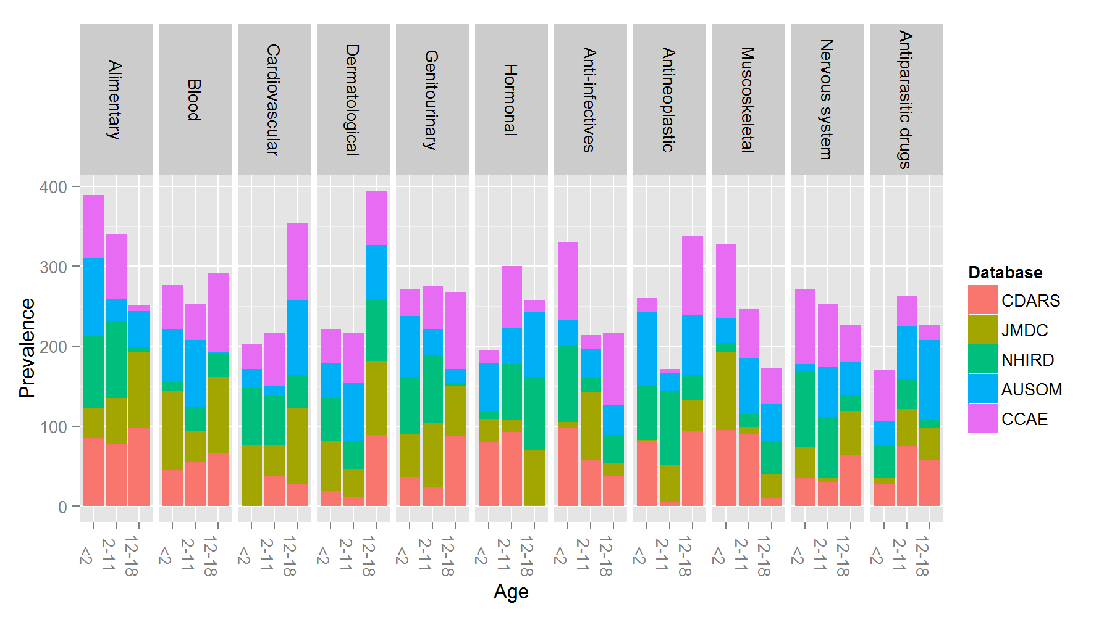

Fake date for illustration only

Figure 1b: User prevalence, per anatomical class, age group, and database in an ambulatory care setting.



Fake date for illustration only

Figure 2a: User prevalence, per anatomical class, gender, and database in an inpatient setting. 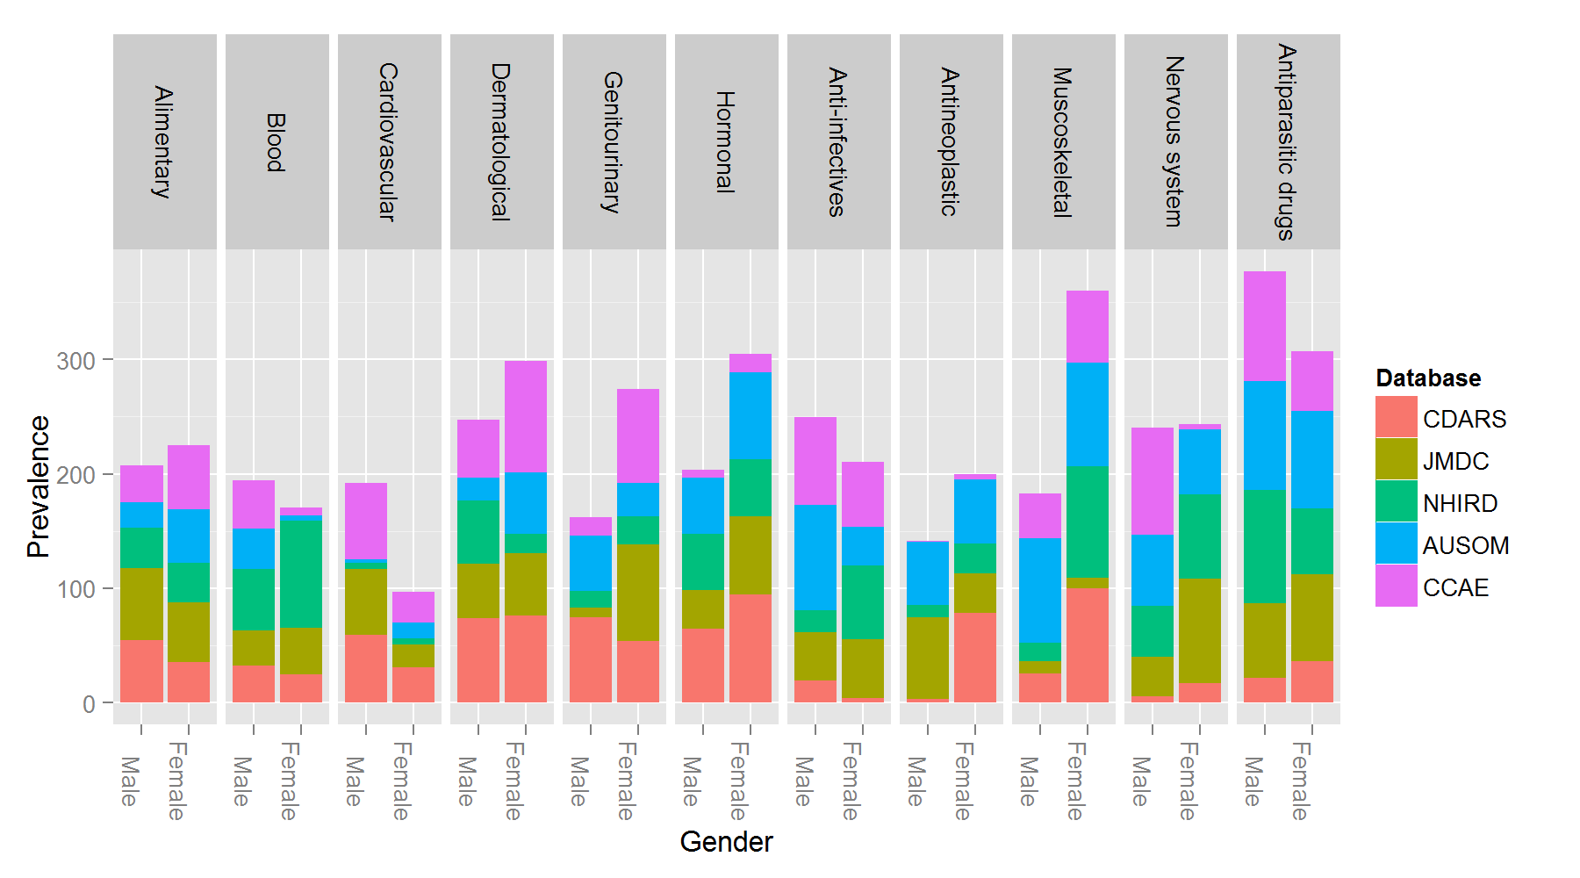

Fake date for illustration only

Figure 2b: User prevalence, per anatomical class, gender, and database in an ambulatory care setting.



Fake date for illustration only

Figures 3a: User prevalence, per anatomical class, age group, calendar year, and database in an in-patient setting. 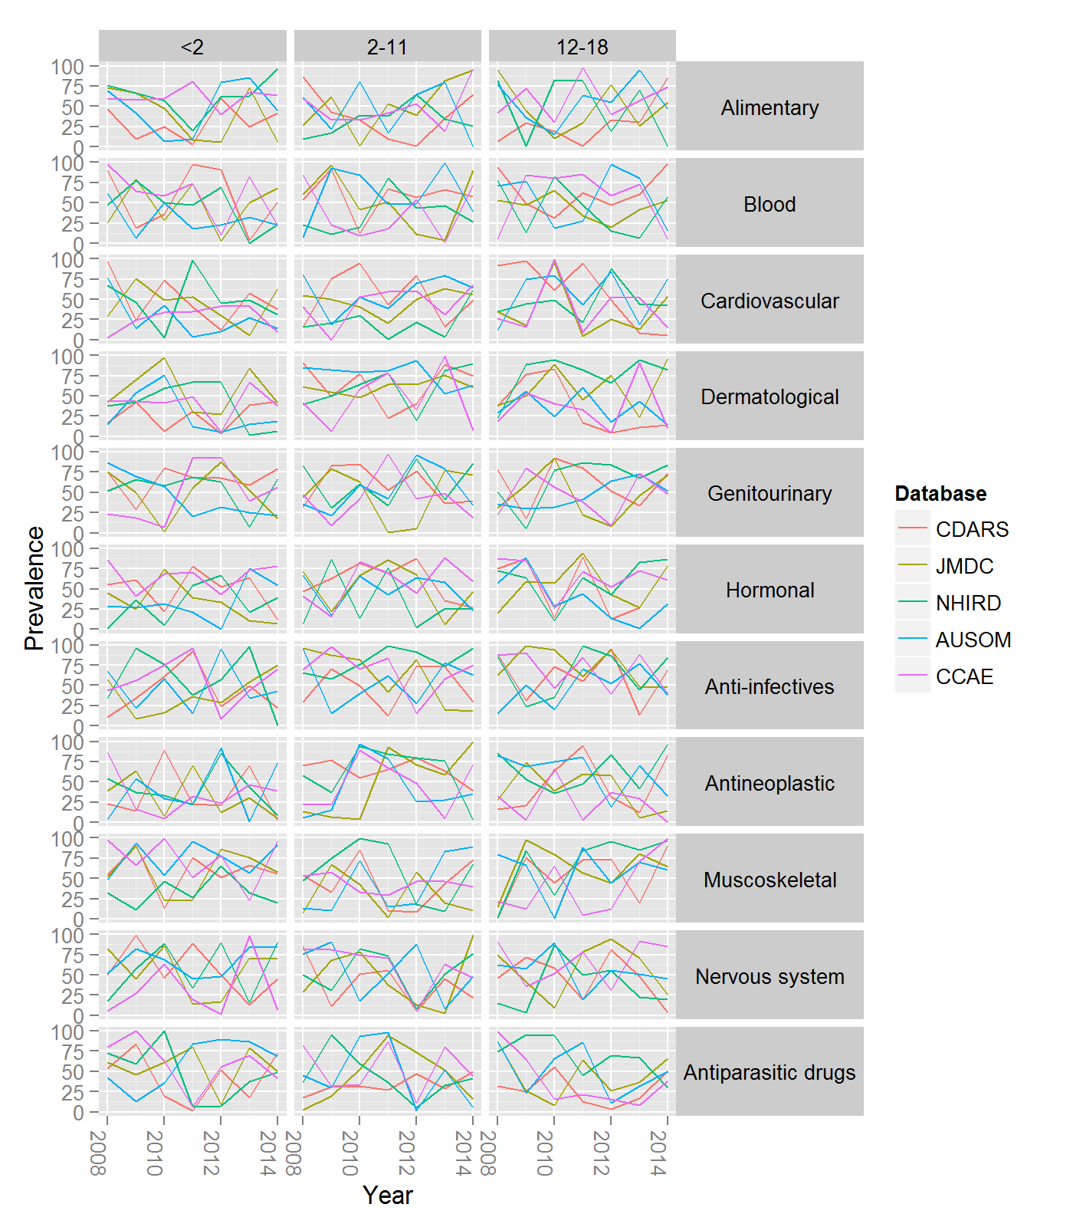

Fake date for illustration only

Figures 3b: User prevalence, per anatomical class, age group, calendar year, and database in an ambulatory care setting.



Fake date for illustration only

# References

1 Sturkenboom MC, Verhamme KM, Nicolosi A, et al. Drug use in children: cohort study in three European countries. BMJ (Clinical research ed). 2008;**337**:a2245.

2 Chan EW, Lau WC, Leung WK, et al. Prevention of Dabigatran-Related Gastrointestinal Bleeding With Gastroprotective Agents: A Population-Based Study. Gastroenterology. 2015 Sep;**149**(3):586-95 e3.

3 Chui CS, Man KK, Cheng CL, et al. An investigation of the potential association between retinal detachment and oral fluoroquinolones: a self-controlled case series study. The Journal of antimicrobial chemotherapy. 2014 Sep;**69**(9):2563-7.

4 Man KK, Chan EW, Coghill D, et al. Methylphenidate and the risk of trauma. Pediatrics. 2015 Jan;**135**(1):40-8.

5 Rose K, Stötter H. ICH E 11: clinical investigation of medicinal products in the paediatric population. In: Rose K, JN vdA, editors. Guide to paediatric clinical research. Basel: KArger; 2007. p. 33-7.